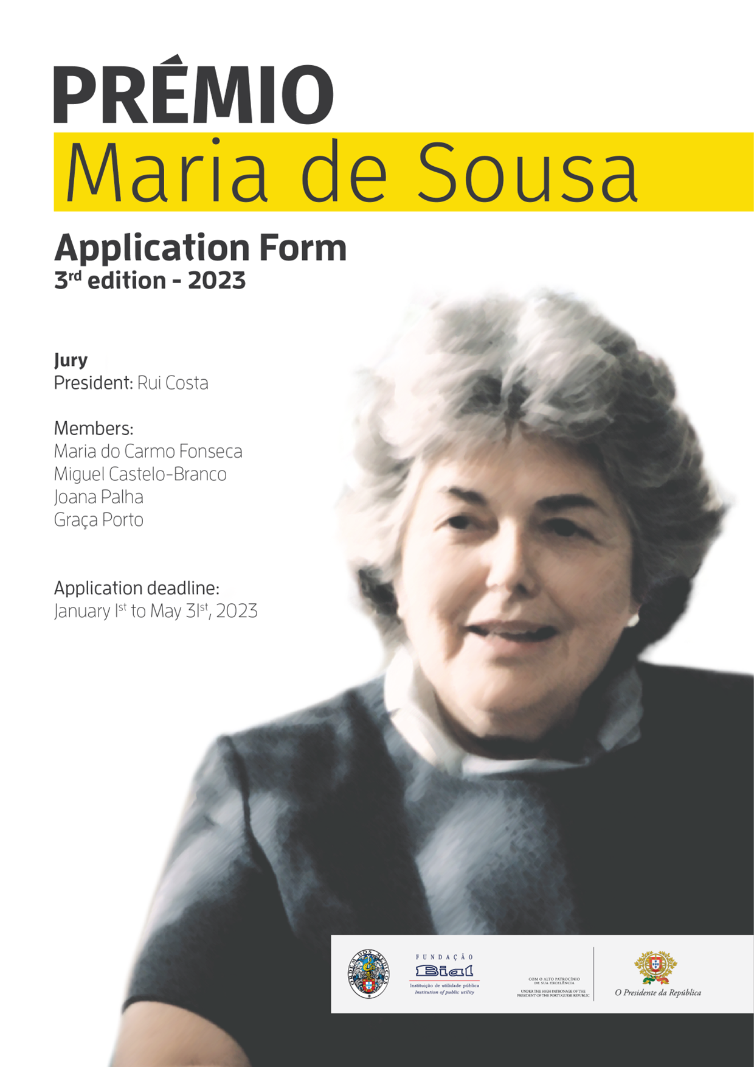

- IDENTIFICATION OF THE RESEARCHER AND THE RESEARCH PROJECT IN THE AREA OF HEALTH SCIENCES

1.1. Researcher’s Identification:
Full name:
Professional name: |  | ORCID ID:
Date of birth: (choose a date) |  | Place of birth:
☐ ID Card ☐ Passport No. |  |  | Valid until: (choose a date)
Taxpayer identification number:
Address:
Town: | Postcode: |  | Country:
Telephone number: |  | Mobile number:
Email address:
Education: ☐ Master's degree ☐ PhD ☐ Other. Please specify.

1.2. Title of the Research Project in Portuguese and in English
Portuguese:
English:

1.3. Host Entity where the Research Project will be developed
University/Institution’s Name:
Research Centre/Department/Laboratory:
Address:
Postcode: | Town: | Country:
Telephone number | Email address: | Taxpayer number:
Research Centre's Director:
Research Centre goals, activities and mission:

1.4. International Centre of Excellence where the International Internship will be developed:
Institution’s Name:
Research Centre/Department/Laboratory:
Address:
Postcode: | Town: | Country:
Telephone number | Email address:
Research Centre's Director:
Research Centre goals, activities and mission:

1.5. Total amount requested (up to € 30,000):
Euro: €

1.6. Project start and end dates/ Project duration in months:
(Please note: maximum period of 2 consecutive years)
Start date: (choose a date) | End date: (choose a date)
Number of months:

1.7. International Internship start and end dates in months:
(Please note: minimum period of 4 months included in the maximum period of 2 years for the development of the Project)
Start date: (choose a date) | End date: (choose a date)
Number of months:

1.8. Ethical Issues
Does the Research Project involve animals?
Yes ☐ | No ☐
If yes, did you attach documentary evidence of the Research Project submission to approval by the competent Ethics Committee(s) / Authority(ies)?
Yes ☐ | No ☐
If yes, did you attach documentary evidence of the Research Project approval by the competent Ethics Committee(s) / Authority(ies) (if approval already exists)?
Yes ☐ | No ☐
Does the Research Project involve human subjects?
Yes ☐ | No ☐
If yes, did you attach documentary evidence of the Research Project submission to approval by the competent Ethics Committee(s) / Authority(ies)?
Yes ☐ | No ☐
If yes, did you attach documentary evidence of the Research Project approval by the competent Ethics Committee(s) / Authority(ies) (if approval already exists)?
Yes ☐ | No ☐

- STATEMENT OF INTENT AND SCIENTIFIC COMPONENT

2.1. Statement of intent, including Researcher's motivation in developing the Research Project and demonstration of its importance.
(Please note: limit of 12,000 characters, including spaces)

2.2. Abstract of the Scientific Research Project
(Please note: limit of 5,000 characters, including spaces)

2.3. Research Plan and Methods
(Please note: limit of 10,000 characters, including spaces)

2.4. Project Scheduling
(Please note: limit of 1,500 characters, including spaces)

2.5. References

- FINANCIAL COMPONENT

3.1. Cost Estimate (in Euro)
Description / item | Amount / [YEAR] | Amount / [YEAR]
 | € / YYYY | € / YYYY
 | € / YYYY | € / YYYY
 | € / YYYY | € / YYYY
 | € / YYYY | € / YYYY
 | € / YYYY | € / YYYY
 | € / YYYY | € / YYYY
 | € / YYYY | € / YYYY
 | € / YYYY | € / YYYY
 | € / YYYY | € / YYYY
 | € / YYYY | € / YYYY
 | € / YYYY | € / YYYY
 | € / YYYY | € / YYYY
 | € / YYYY | € / YYYY
 | € / YYYY | € / YYYY
TOTAL | € / YYYY | € / YYYY

3.2. Cost Estimate justification, namely equipment, if applicable:
(Please note: limit of 3,000 characters, including spaces)

- ATTACHMENTS

Please attach:
- - Tables, drawings, or images (optional).
- - Curriculum Vitae 4 pages maximum.
- - Declaration of acceptance of the applicant researcher by the Host Entity where the Project will be developed.
- - Declaration(s) of the Research Project submission to approval by the competent Ethics Committee(s) / Authority(ies) of the Research Project approval by the competent Ethics Committee(s) / Authority(ies), if applicable.

Information of personal data processing by the BIAL Foundation is available at Privacy Policy.
Please note: Applications must be sent in a single editable/unrestricted PDF document, the title of which must include the first and last name of the Researcher. The order of the documents that will integrate the file to be sent should be: this application form, followed by the documentation in the order indicated in this item.

Statement of Acceptance and Consent

☐ | I hereby declare that I read, understood and accept, with no reservations, the conditions outlined in the Regulation for the MARIA DE SOUSA AWARD, available at www.ordemdosmedicos.pt and www.fundacaobial.com, which I have acknowledged. Moreover, I declare that I filled in and agree with the information provided in the Application Form.

If you would like to receive further information about BIAL Foundation's activities, please check the following field:

☐ | I would like to receive further information about informative and/or promotional events and campaigns related to BIAL Foundation.

You have learned about the MARIA DE SOUSA AWARD for the first time through:

☐ | Website | ☐ | Social Networks | ☐ | News in the media | ☐ | Media advertising | ☐ | Mailing | ☐ | Other. Which?

